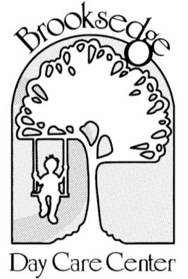

Credit Card Payment Authorization Form

Family Name: _______________________________ Begin Charging Card On: _________________

I ________________________________________, hereby authorize Brooksedge Day Care Center to bill my credit card for the purpose of childcare tuition and fees. I understand that this authorization will remain in effect until written cancellation is received by Brooksedge Day Care Center. Any changes to payment amounts and advance payment amounts must be communicated and emailed to
brooksedgehilliard@yahoo.com by Friday at noon. I further agree to notify Brooksedge Day Care Center of any changes in account information.

Charge Card (circle one): Weekly Bi-Weekly Monthly
(payment in advance)

Credit Card Type: | □Visa □American Express □ Discover □Mastercard □Other
Card Number: |  | Expiration Date:
Cardholder’s Name: |  | Security Code:
Billing Address:
City, State, Zip Code:
By signing this authorization, I acknowledge that I have read and agree to all of the above. All information given is complete and accurate.
Authorized Signature: |  | Date:

Date of Charge | Charged Amount | Dates of Service | Date of Charge | Charged Amount | Dates of Service

